How did Manchester City Council’s expenditure change between Q4 2024 - Q1 2025?
Milena Musiienko (w2160392)

Tracking how a city council spends its money might not sound like an existing activity, but it is surprisingly revealing. Manchester City Council handles millions of pounds across dozens of services, from Adult Social Care to Bed & Breakfast accounts for children in need. If the citizens do not keep an eye on it, no one else will.
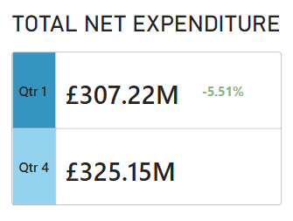
In line with the Government’s requirement that local authorities publish details of their expenditure in excess of £500, Manchester City Council publishes this dataset on a monthly basis (1). This report will focus on the changes in expenditure and financial distributions for Q4 2024-Q1 2025, as comparing one quarter to the next shows whether money is being used wisely.
Overall Net Expenditure dropped in Q1 2025. A decrease of 5.51% seems like a small change, but it actually signifies that approximately 17.93 million pounds were saved for future expenses. It’s a win!
But what has changed in the financial structure? Let’s look at the service areas with the highest expenses. In Q4 2024, Adult Social Care received around 64 million pounds from the Council, while in Q1 2025 the amount suddenly dropped to 28 million. Even so the list of top service areas stayed the same with Corporate Services and Children & Education Services remaining in the top 3.
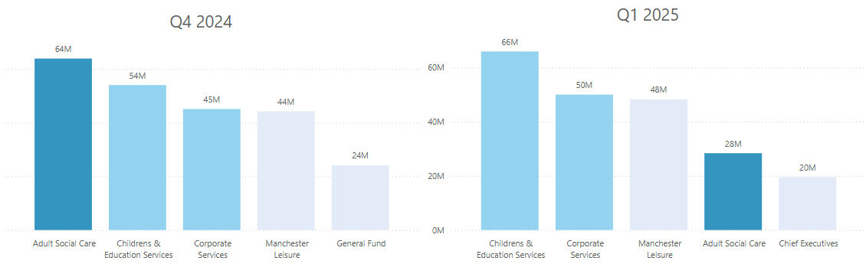

REFERENCES
- Pay Policy Statement https://www.manchester.gov.uk/open/downloads/file/1459/pay_policy_statement_2025

